**EXPERIMENT 1.2**

**EXPERIMENT 1.3**

**EXPERIMENT 1.4**

**EXPERIMENT 1.5**

**EXPERIMENT 1.6**

**EXPERIMENT 1.7**

**EXPERIMENT 1.8**

**EXPERIMENT 1.9**

**EXPERIMENT 1.10**

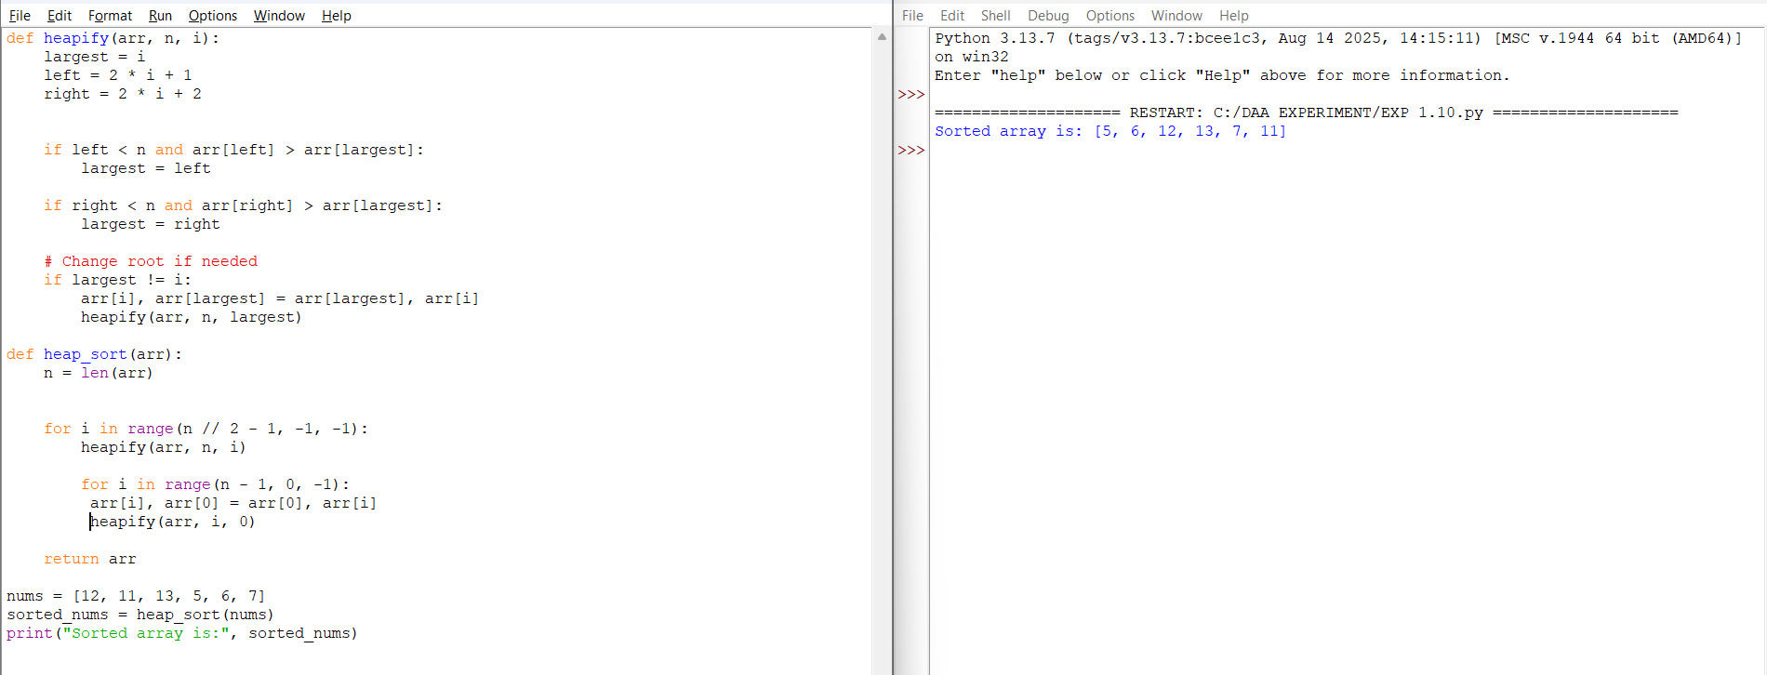

**EXPERIMENT 1.11**

**EXPERIMENT 1.12**

**EXPERIMENT 1.13**

**EXPERIMENT 1.14**

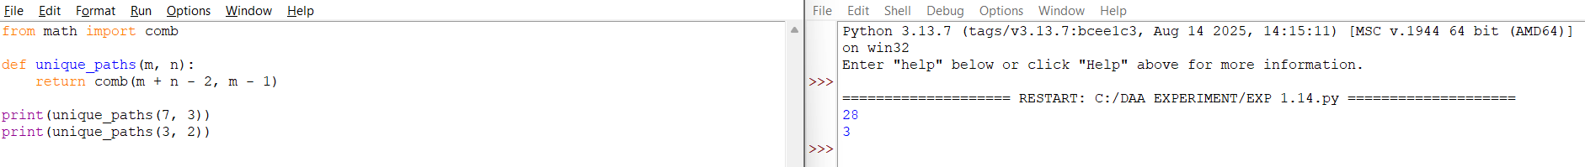

**EXPERIMENT 1.15**

**EXPERIMENT 1.16**

**EXPERIMENT 1.17**

